Pract 4- Configure Ip Routing Using Rip

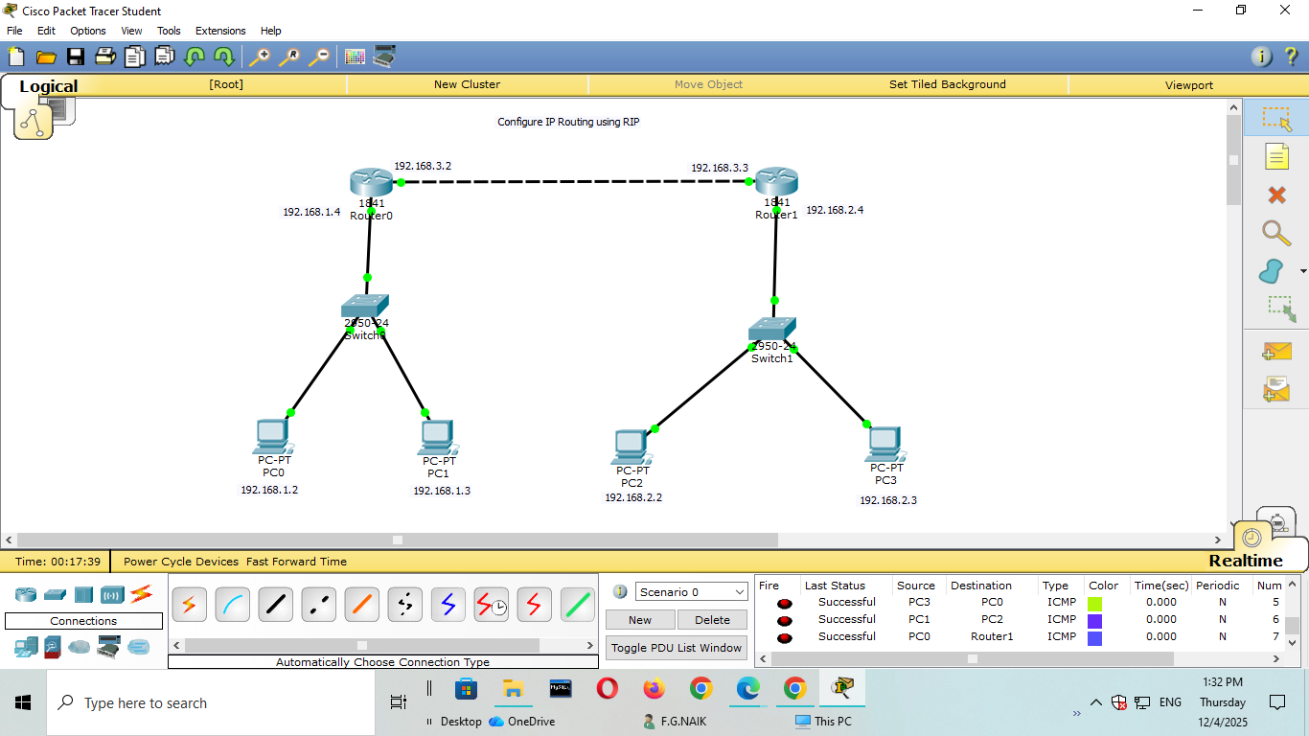
Step1: Configure all the pcs and routers with the above given ip addresses
Step2: After config go to each router and add network addresses.
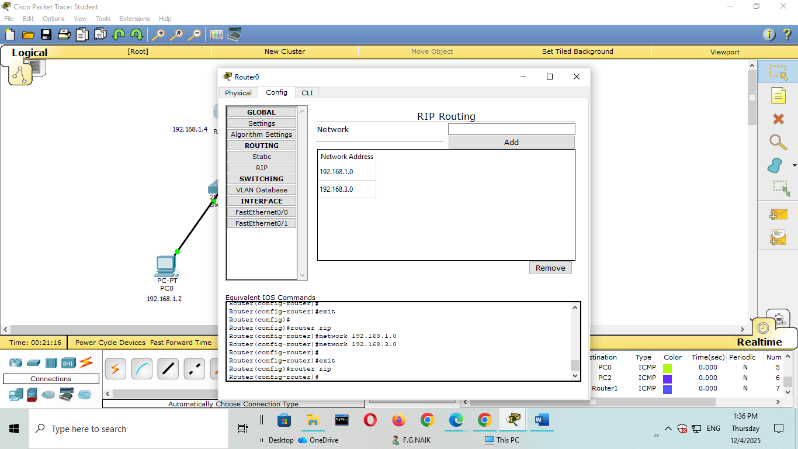

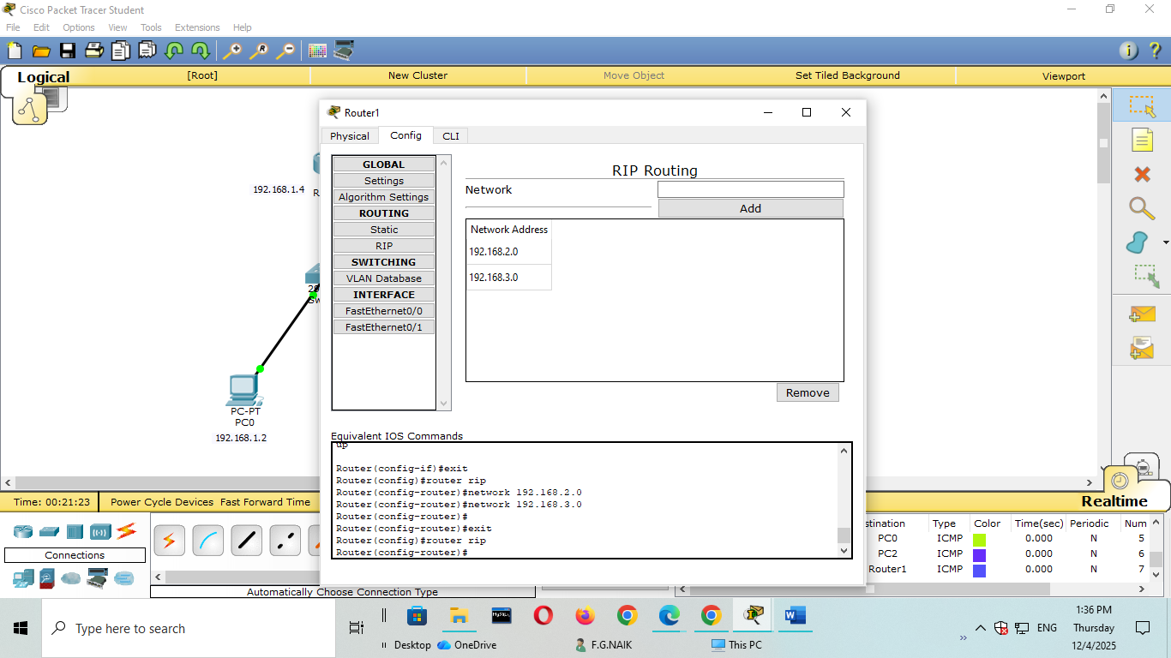

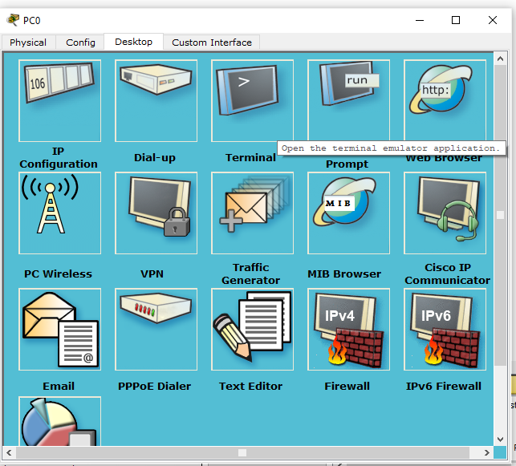
Ping the pc2 from pc0
